Channel Switch Mod:

The channel switch mod enables your transmitter to switch between any of the AeroAce channels (A, B or C). Once you do this mod you will only have to carry one transmitter to the flying field.

The modification requires a toggle switch, SPDT with a center “off” position. The one used in this modification is a Radio Shack switch P/N:275-325. Start by opening the case:

Start by unscrewing the transmitter antenna and remove. Next flip the transmitter over, and remove the four visible screws.
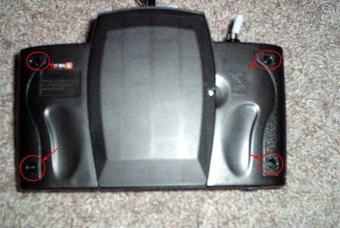
Remove the battery cover. There are three additional screws inside the cover where the batteries go. Remove them.
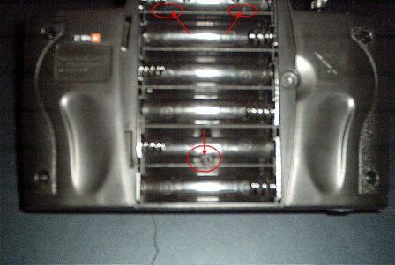
Slit the sticker where the antenna goes in. This will allow you to open the case. Remember that the case will open only so far, because of the charge cable!

You need to cut a hole in the case for the switch. The best place for this is the upper left hand corner of the case.
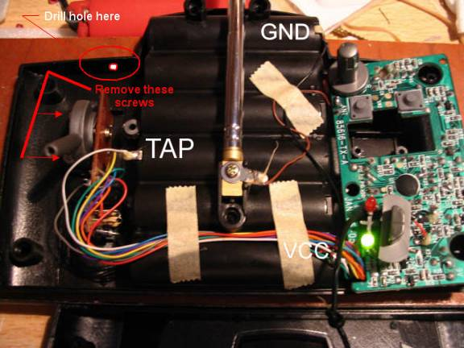
Three wires need to be routed from the switch down to the bottom of the case, then across the battery compartment to the circuit board on the other side. You want to cut the wires long enough, so that they do not cross over the transmitter antenna.
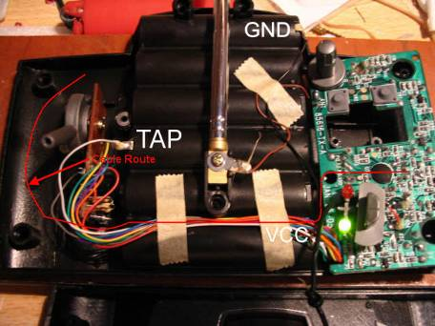
Due to the confined space, I would recommend cutting and soldier the wires to the PC board and switch, then installing it.

To install the switch once you have the wires installed, you will need to temporarily remove the throttle stick assembly, so the switch can fit in. This is done by removing the two screws to the left of the throttle stick.
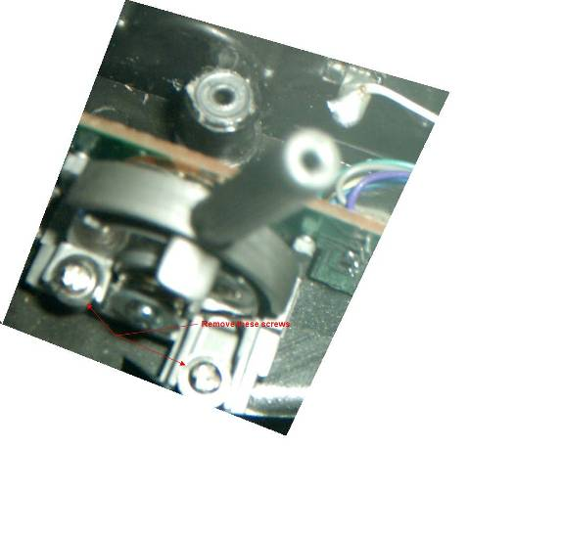

Install the switch, and route the wires. The center connection (common) on the switch will go to the “A” channel connection pad on the PC board.
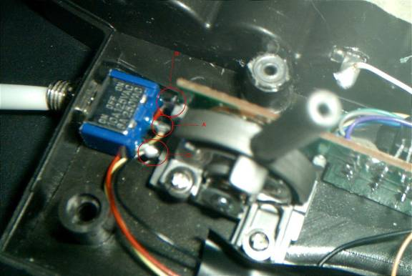

Once this is done, reinstall the throttle stick assembly. The wires from the switch need to be soldiered to the circuit board as follows:
“C” connection: The pad below and to the right of R11
“B” connection: The pad right above the “R19” silkscreen labeling
“A” connection: The diagonal pad which comes from R14, on its upper left.

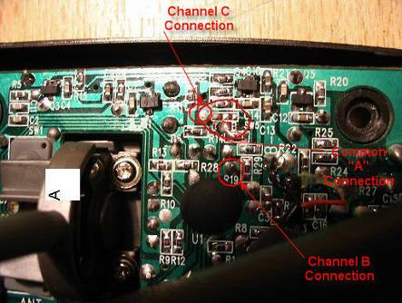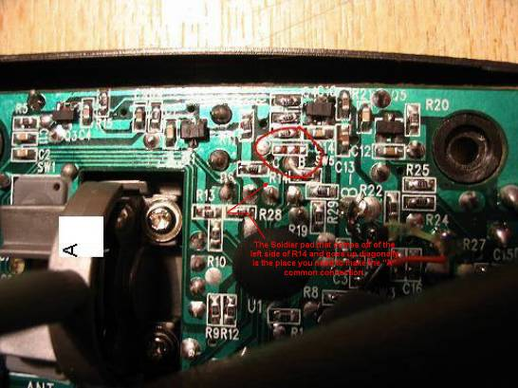
Test the transmitter by switching between any of the channel switch positions with the transmitter off. Add labeling if desired. That’s it!
